**MECHTRON 3TB4 Lab 1 Prelab**

**Part 1:**

During the Lab 1 Tutorial, we installed Quartus Prime and created our first basic project to get familiar with the software. For our very first project, we implemented a simple XOR gate. We learned how to create the Verilog script to implement the logic for the XOR gate.

**Figure 1:** Screenshot of our XOR gate code in Verilog

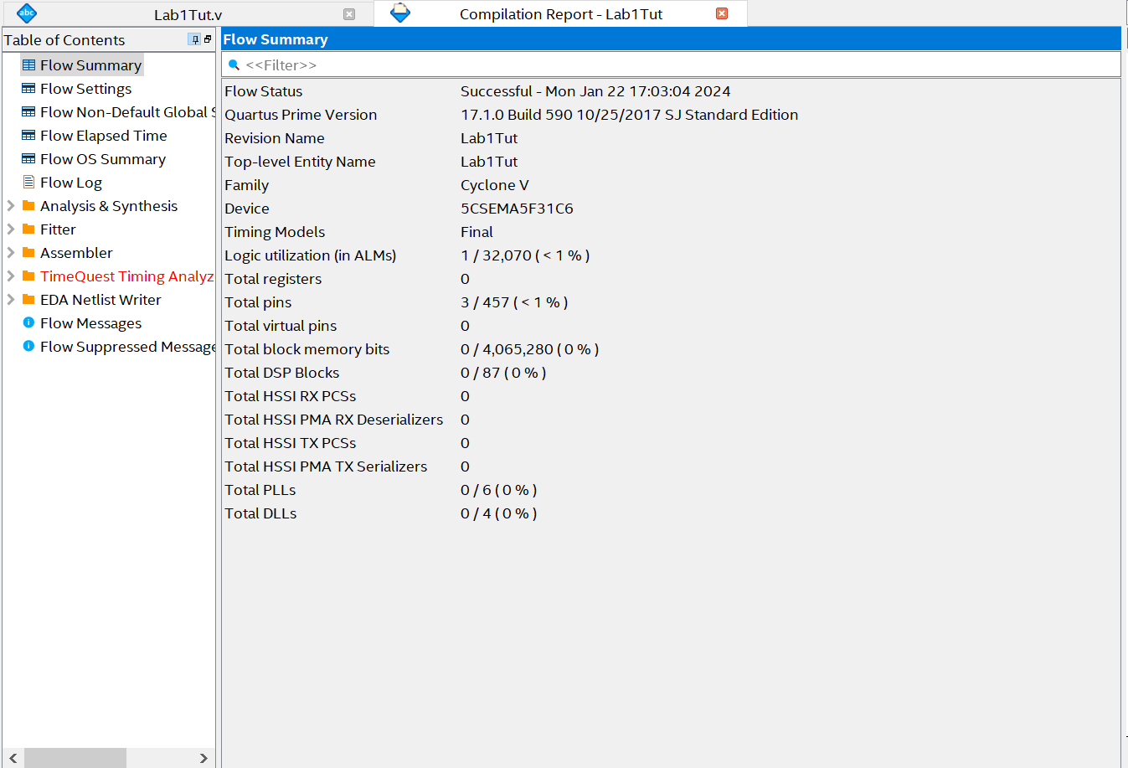Once the script was made, we made sure to compile our project to ensure there weren’t any errors.

**Figure 2:** Screenshot of our XOR gate project compilation report

Once our project compiled, we then ran a simulation to verify the results of our project.

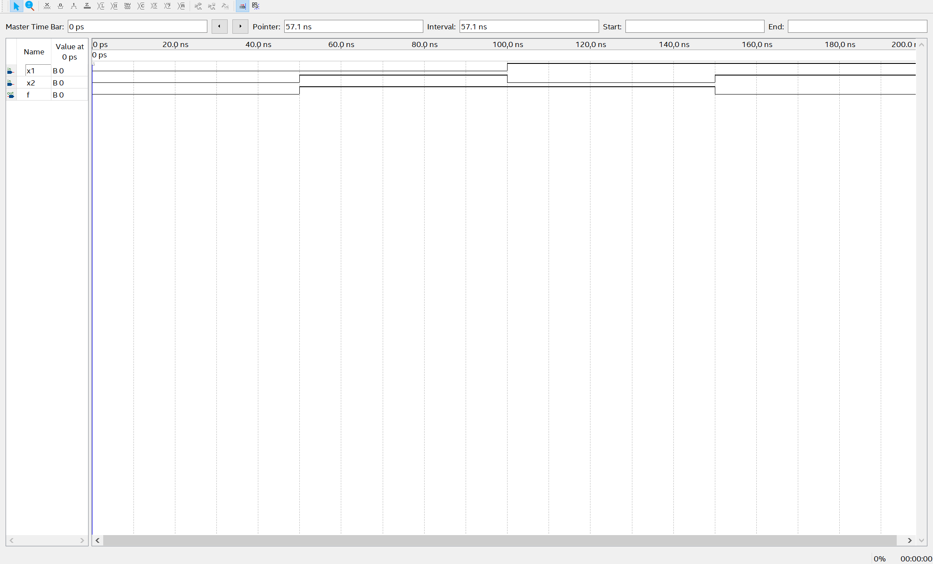

**Figure 3:** Screenshot of our XOR gate project simulation results